Zovuyo Innovations — Smart GrowKit
Living Architecture & Team Lead Document
Version 0.1 — Living draft · 7 September 2026 · Audience: mechanical, electronics, firmware, cloud, advisors
This pack leads incoming engineering teams. Structure first, then IoT layers, then control-loop algorithms. Greenhouse / Greenspace farmer systems are phase two — not the first ship.

1. Labelled drawings

1.1 Three-tier structure
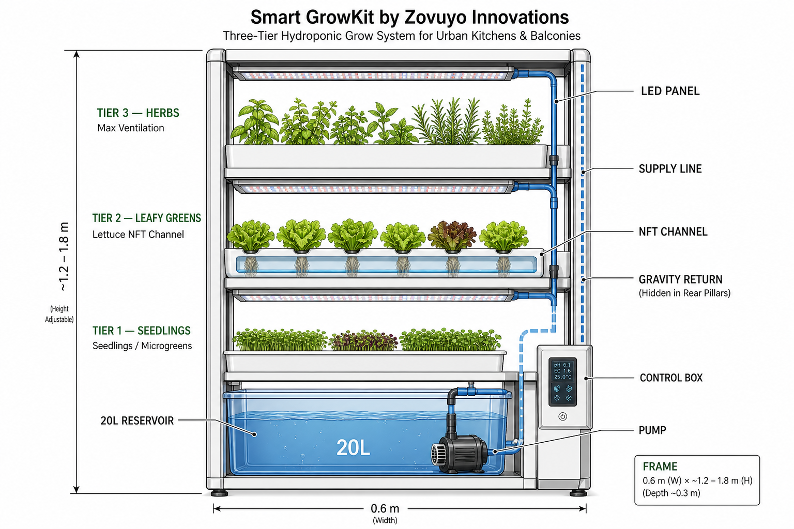
Figure 1 — Three hydroponic beds, shared 20 L reservoir, supply riser, gravity return, control box.

1.2 IoT architecture (sensors → controls)
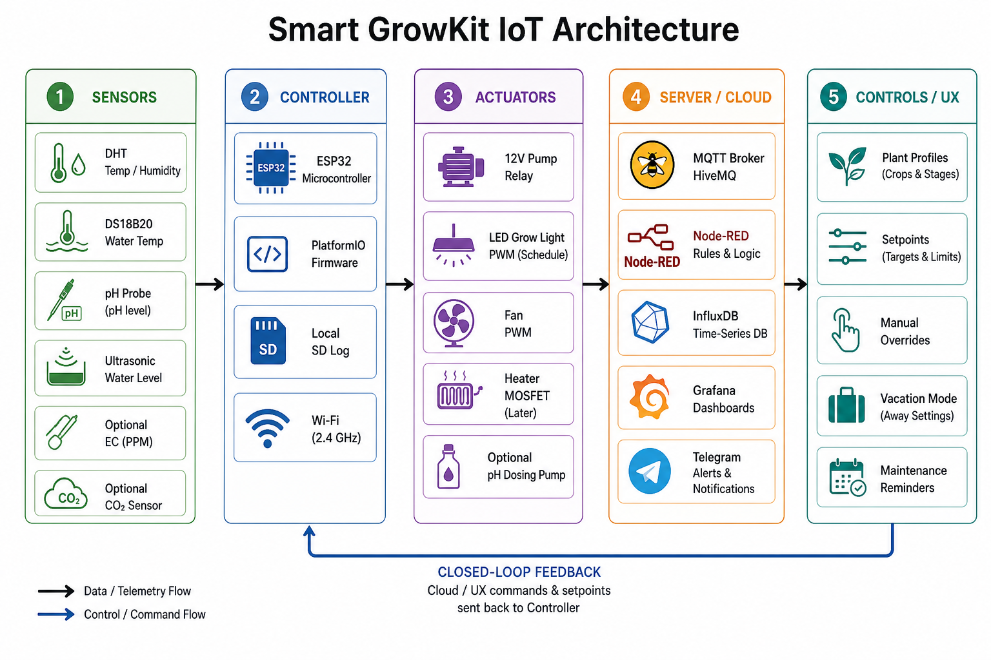
Figure 2 — Five layers: Sensors, Controller (ESP32), Actuators, Server/Cloud, Controls/UX, with closed-loop feedback.

1.3 Control loops & safety supervisor
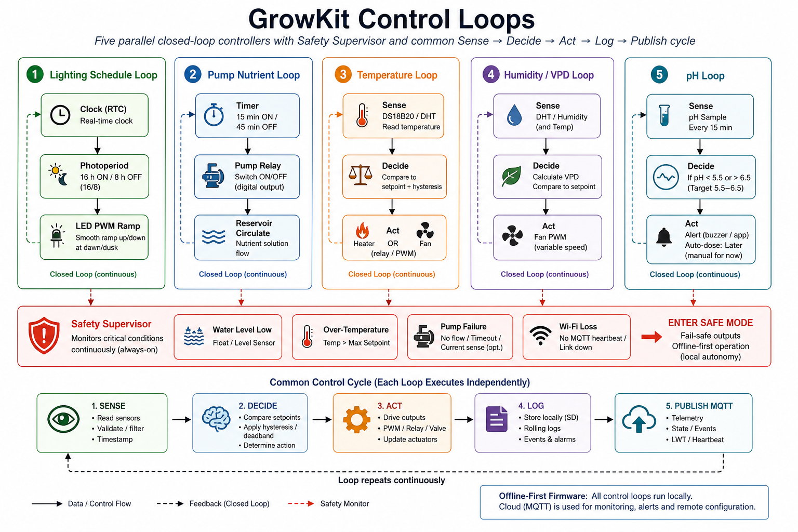
Figure 3 — Lighting, pump, temperature, humidity, pH loops + always-on safety supervisor. Offline-first.

2. Product north star
- Smart GrowKit: compact IoT three-layer hydroponic appliance for urban SA homes.
- Demo defaults: ~0.6×0.4 m footprint, 1.2–1.8 m height for three beds, 20 L reservoir, pump 15 min ON / 45 min OFF, ESP32, HiveMQ→Node-RED→Influx→Grafana+Telegram.
- Retail ambition R5k–R8k class. Primary product = home GrowKit; greenhouse later.

3. Team map
Team / lane | Owns | Primary artefacts
A — Structure & hydro | Frame, beds, plumbing, reservoir, LED mounts | CAD, mechanical BOM, § structure
B — Power & electronics | PSU, fuse, bucks, relays, control box | Schematics, proto/PCB
C — Firmware | ESP32 loops, drivers, safe mode, MQTT | PlatformIO repo
D — Cloud & UX | Broker, Node-RED, Influx/Grafana, Telegram | Dashboards, topic contracts
E — Product / compliance | Brand, POPIA, SANS/NRCS roadmap, demo script | Decision log, risks

4. Three-layer structure summary
Tier | Role | Typical crop | Notes
Tier 3 (top) | Max ventilation | Herbs | Warmest / most airflow
Tier 2 (middle) | Main production | Lettuce NFT | Primary demo bed
Tier 1 (bottom) | Nursery | Seedlings / microgreens | Protected
MVP plumbing: one pump feeds up; gravity return down; shared reservoir sensing (pH/level/temp) — not per-bed probes yet.

5. IoT layers (names to use everywhere)
- 1 Sensors — DHT, DS18B20, pH, level (± EC/CO₂ later)
- 2 Controller — ESP32, PlatformIO, SD log, Wi-Fi
- 3 Actuators — pump relay, LED PWM, fan PWM (± heater/dose later)
- 4 Server/cloud — HiveMQ, Node-RED, InfluxDB, Grafana, Telegram
- 5 Controls/UX — profiles, setpoints, overrides, vacation, maintenance
- Hard rule: layers 1–3 keep plants alive offline; cloud is observability + remote config.

6. Control-loop algorithms
Common cycle: SENSE → DECIDE → ACT → LOG → PUBLISH MQTT
- L1 Lighting — 16/8 photoperiod, soft PWM ramp
- L2 Pump — 15 ON / 45 OFF; inhibit on low level
- L3 Temperature — fan cool / heater heat with hysteresis
- L4 Humidity — fan PWM / VPD assist
- L5 pH — sample every 15 min; alert only in MVP (auto-dose later)
- Safety supervisor — low water, over-temp, sensor loss, Wi-Fi loss → SAFE MODE

7. Decision log (seed)
- 2026-09-07 — Primary product = home Smart GrowKit; greenhouse later (Oluhle)
- 2026-09-07 — Demo defaults: 20 L, 15/45 pump, ESP32, free MQTT stack
- 2026-09-07 — Physical intent = three stacked beds with shared nutrient delivery (Oluhle)

8. Open decisions
- D1 Exact prototype height (1.2 m vs 1.5–1.8 m)
- D2 Primary DC rail (12 V vs 24 V front-end)
- D3 Bed tech per tier (all NFT vs mixed)
- D4 Brand mark on demo UI (Zovuyo / Smart GrowKit)
- D5 EC & CO₂ on first wet demo?
Full prose, mermaid, MQTT contract, and checklists: see companion Markdown in this pack.

